**Order Handling**

This is the back office to help you handle the orders. From here, you can also create new orders, and the orders are displayed in three different lists that are:

* All Orders
* Unpaid Orders
* Unfulfilled Orders

ORDERS >> ORDERS

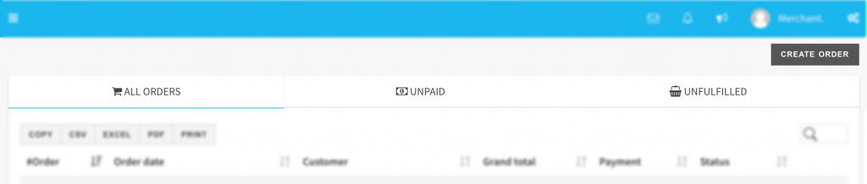

 This module has order handling sections that are:

* Order Fulfilment
* Create An Order

**Order Fulfilment**

To fulfill one order, visit ORDERS >> ORDERS, and then click over the UNFULFILLED tab, and then find the order that you wish to fulfill first. Now select the ORDER NUMBER on the #Order column of the table having the list of all the orders. Now, on the next screen, mark the orders as PAID or UNPAID.

**Tips!** Use the search box available at the top right corner to find the order from the order list table.

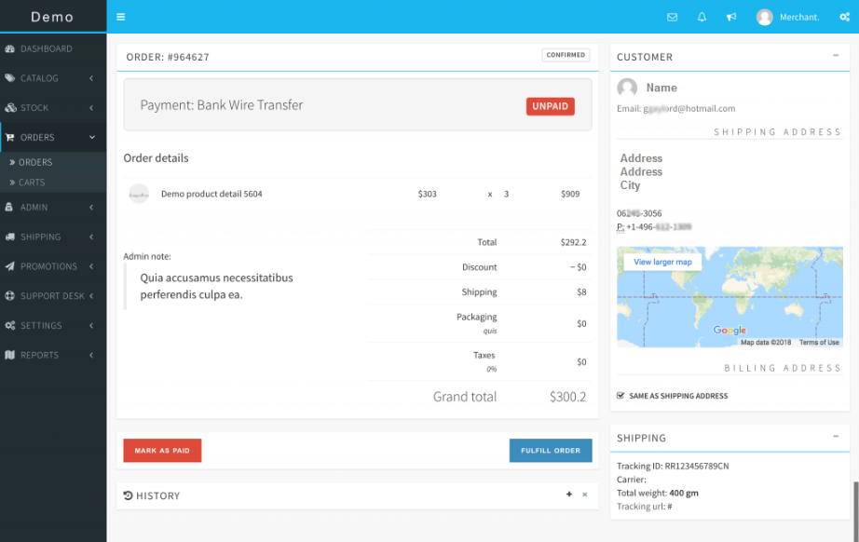

If you have already shipped and fulfilled the order, click on the FULFIL ORDER button to update the status. Moving on to the next screen, you can also select the shipping carrier and update the tracking details of the order so that the customers can track their shipments. A notification can also be sent to the customer for the updates.

**Create An order**

You might also need to create an order, and that is possible easily with the simple interface of IndoMarche that has all the features to create an order.

For creating an order, go to ORDERS >> ORDERS and then click on CREATE ORDER. On the next screen, find the customer for whom the order is to be created. As soon as you type the name, email, and other details, the result will be displayed. Select the customer and select the PROCEED button to populate the order form.

ORDERS >> ORDERS >> CREATE ORDER

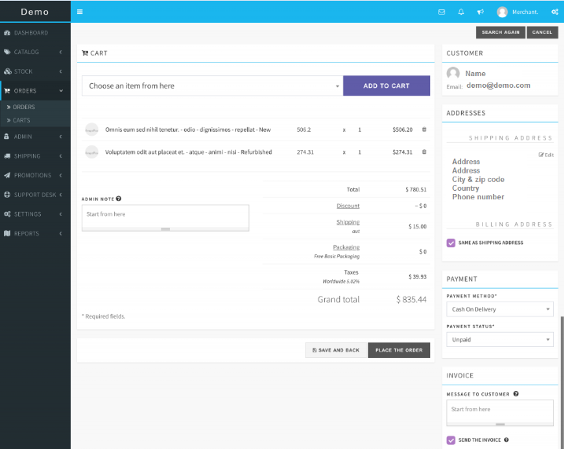

The screen of order creation is self-descriptive. To proceed later with the order and save it for the time being, you can just click on SAVE AND BACK button. And, to create the order, select the PLACE THE ORDER button.

*Use Saved Cart for creating the order*

To place an order from the saved items in the cart, go to ORDERS >> CARTS and find the cart to proceed with. Finally, click on the USE button to process the order